Eastern Early Music Forum
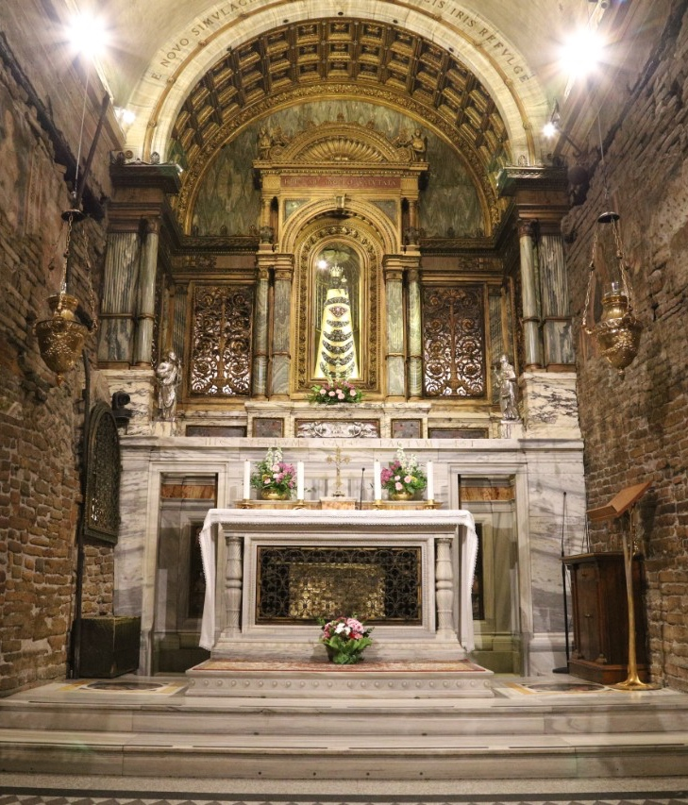
Messa La Luna Piena
(The ‘Full Moon’ Mass) in 8 parts

by Giuseppe Corsi da Celano

A workshop for singers and instruments

Tutor: George Parris
Saturday 1st March 2025
Castle Street Methodist Church,
Castle Street, Cambridge CB2 0AH

Music: This workshop, with choir conductor and singer George Parris, explores an exquisite Italian work from Giuseppe Corsi da Celano (1631/32 - 1691), an almost forgotten Italian composer. Born to a noble family, Corsi is known to have been a priest and also had a wife and children. He worked in Loreto and then had a busy career as one of Rome’s foremost maestri di cappella. We know little about the Mass’s date of composition or why it is called ’The Full Moon’, but he had finished it before his incarceration between 1577 and 1581 at the Albornoz Fortress in Narni for alleged rape. The work is florid, tuneful and inventive, with moments of daring and colourful harmony combined with gestures of grand opulence. The Mass is scored for two SATB choirs, and we welcome applications from all singers and instrumentalists, including continuo players. A = 440

Tutor: George Parris trained as an early-music singer and then studied choral conducting and ensemble singing at the Sibelius Academy in Helsinki. In 2011 he founded The Carice Singers, now a professional ensemble, and he works across Europe as a singer, chorus master, and conductor. His work is varied and far-reaching, from being Artistic Director of the Aurore Renaissance Music Festival in Helsinki, performing vocal works by Kaija Saariaho and Luciano Berio, and mentoring the next generation of choral composers on schemes for Cheltenham Music Festival, Spitalfields Music Festival and the Three Choirs Festival.

Venue and practical information: The workshop will begin with coffee or tea at 10.15am, with the music starting at 10.45; we will finish around 5.00pm. Castle Street Methodist Church has pedestrian entrances on Castle Street itself (through the iron gate) and also on St Peter’s Street. There are a number of free parking spaces at the venue itself with the entrance on St Peter’s Street – if you do not know Cambridge, you are advised to use your satnav or google maps around the gyratory system to get to St Peter’s Street. There is also parking 2 minutes’ walk away at Shire Hall for £1.60 per hour (this is cheap by Cambridge standards!). More parking is available 5 minutes away at Castle Hill car park (going up the hill turn right immediately after the Sir Isaac Newton pub, signposted long stay.

The guided bus route A from the railway station (stop 9) takes about 20 minutes and buses leave the station at 9.46 and 10.16 am. Ask for the Shire Hall stop and walk back down the hill a little way to Church, using the pedestrian access to the hall through the iron gate on Castle Street or via St Peter’s Street. You can also catch the guided bus from venues north of Cambridge to the Shire Hall stop.

If you require any further assistance with public transport please contact Janet Tanburn at janetmtanburn@gmail.com or tel. 01954 718842 (preferred) or mobile 07842 219258 on the day of the workshop (network coverage at home is not perfect!).

Lunch is not provided but there are pubs with both inside and open-air venues within very easy walking distance, or you may bring your own.

COVID and flu precautions:
We continue to ask participants to be cautious. At one of our recent workshops a number of people caught covid as, in spite of our request, at least one person did not heed the requirements below. Although covid is no longer as dangerous as it once was, it still ruins a week or two of your life and can leave long term effects including loss of energy or damage to the voice. You are kindly therefore asked to consider other participants and take these precautions:
- The venue is relatively spacious, and will be ventilated, so please dress accordingly.
- As a courtesy to other participants, we still ask you to take a lateral flow test before attending, and you should obviously not attend if you test positive.
- You should not attend if you have symptoms that could indicate Covid, or indeed other illnesses (e.g. fever, coughing, loss or change to your sense of smell, taste or appetite, shortness of breath, feeling tired or exhausted, aching body or headache, sore throat, runny nose, diarrhoea, feeling sick).
If you are unable to attend as a result of ill health your fees will be refunded to you.

Cost: £22 for members of EMF, or £25 for non-members, £5 for students. (If you are not already a member, EEMF’s annual subscription is only £6 if paid by Standing Order!)

To apply please complete and return the application below in any way you prefer (or just put the essential information in an email) and send it to Janet at janetmtanburn@gmail.com (preferred method) or send it by post to Janet Tanburn, 5 Meadow Rise, Bourn, Cambridge, CB23 2TG
(tel 01954 718842).

Please make payment by bank transfer if possible.
A/c name: Eastern Early Music Forum (business account with HSBC bank)
A/c No: 33888401
Sort code: 40-16-08
Reference: Parris [your name].
Cheques will of course be accepted from anyone who is unable, or does not wish, to use electronic banking.

Name

Address

Telephone

Email

Voice or instrument (please specify first and second choices if you are offering more than one)

Payment (Please delete as appropriate)
I have paid by bank transfer / I have enclosed a cheque
I am a member of Early Music Forum
If you can offer a lift, or would like a lift please indicate here:

